## Technical Assessment

**Name: ­­­­­­­­­­­­­ ________________________________________**

Please note that the information contained in this document is private and confidential and should not be shared with others.

This test is divided into two sections. It is designed to test your technical and business knowledge. You are given **60 minutes** for this test.

1. Part I: Technical assessment
2. Part II: Pre-sales and Business Analysis

Please let us know if you have any questions. Good luck.

### **Technical**

**SQL**

1. The Employee table shows information about the employees in Dundas. Note that the **IDs in ManagerID are also EmployeeIDs**, For example, Jenik’s manager is Timothy.

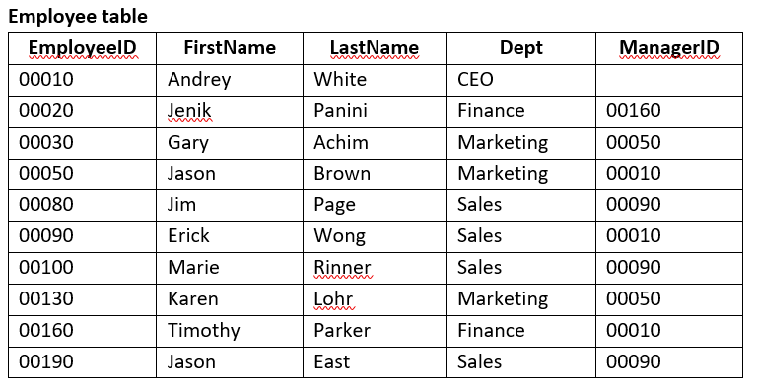

* 1. Write a query returning the full name of every employee containing the letter M in the first name, sorted by last name
  2. Write a query returning the full names of employees that directly report to the CEO. (This query must continue to work if the CEO’s name or employee ID change.)
  3. What department has the largest number of employees?

1. Given the database tables below, find the following:

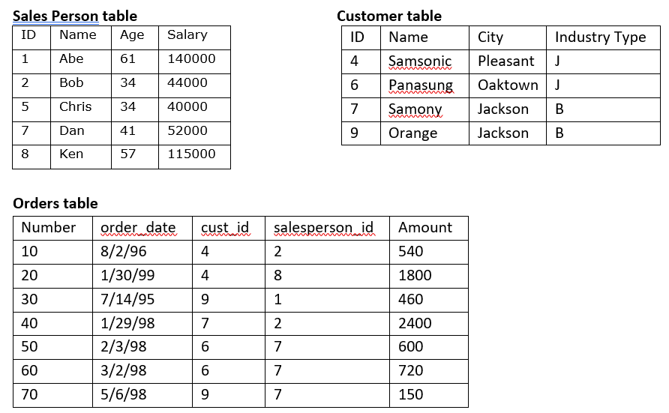

1. Write a query returning the names of sales people with no orders
2. Who is the top sales person overall and what is their sales amount?

**C# and .NET**

1. Please read through the code below and explain what the code is doing

public static bool MethodToIdentify**(**string a**,** string b**)**

**{**

char**[]** char1 **=** a**.**ToLower**().**ToCharArray**();**

char**[]** char2 **=** b**.**ToLower**().**ToCharArray**();**

Array**.**Sort**(**char1**);**

Array**.**Sort**(**char2**);**

string aWord **=** new string**(**char1**);**

string bWord **=** new string**(**char2**);**

if **(**aWord **==** bWord**)** **{**

return true**;**

**}**

else **{**

return false**;**

**}**

**}**

1. Given the base class below, provide a class definition that inherits for the base class.

public class **<**base_class**>** **{**

**...**

**}**

1. What is the value of “z” after the following code runs?

x = { “foo”: “bar” }

y = { “baz”: x }

z = y[“baz”][“foo”]

Select the correct answer:

1. “foo”
2. “baz”
3. Runtime error
4. “bar”
5. “x”

Explain your answer:

1. Write a method to calculate the factorial of a number. Eg: 5! = 120. Hint: Use recursion.

*\*\*It’s okay to write pseudo code if you are not sure about the exact syntax*

public static long Factorial**(**long number**)**

**{**

**}**

**HTML, JavaScript and jQuery**

1. Write code to have the “button” open a new tab and navigate to [www.dundas.com](http://www.dundas.com)
2. Write code to set the color of the label text to red and the font size to 20
3. Write a piece of script that will find the smallest value in a string. For example in the string

var s **=** '5, -12, 3, 8, -5, 0', -12 is the smallest value.

*\*\*It’s okay to write pseudo code if you are not sure about the exact syntax*

function findSmallest**(**s**)**

**{**

**}**

1. Convert the following table into a JSON array called employee. What would the output look like?

**Employees**

|  |  |  |
| --- | --- | --- |
| **firstName** | **lastName** | **salesRegion** |
| John | Doe | Toronto |
| Anna | Smith | Hamilton |
| Peter | Jones | Markham |

### Pre-sales and Business Analysis

1. You are asked to do a presentation to a prospect. What questions would you ask before you go into the presentation?
2. Now imagine you are hired as a business analyst.
   1. In an organization of disparate data sources, what would you do to deliver a successful dashboard initiative? If you need to make any assumptions, please state them. Make sure to explain why you would take each action in your plan.
   2. How would you design the following dashboard with these requirements? A sketch on a piece of paper is acceptable, but be sure to be clear on what you are showing (it’s open for interpretation for a reason, so do your best).

Metrics with sample data:

Sales by Month

|  |  |
| --- | --- |
| SalesMonth | Sales |
| Dec. 1, 2008 | $100,000.00 |
| Jan. 1, 2009 | $150,000.00 |
| Feb. 1, 2009 | $180,000.00 |

Target Sales by Month

|  |  |
| --- | --- |
| SalesMonth | Sales Target |
| Dec. 1, 2008 | $90,000.00 |
| Jan. 1, 2009 | $170,000.00 |
| Feb. 1, 2009 | $150,000.00 |

Rep Sales Performance

|  |  |
| --- | --- |
| Rep | Revenue |
| John | $30,000.00 |
| Harry | $50,000.00 |
| Anna | $90,000.00 |

Sales by US region (NorthEast, NorthWest, SouthEast, SouthWest)

|  |  |
| --- | --- |
| Region | Revenue |
| NorthEast | $130,000.00 |
| NorthWest | $190,000.00 |
| SouthEast | $220,000.00 |
| SouthWest | $320,000.00 |

1. What other metrics do you think would be relevant with this dashboard?